***Exercise 1***

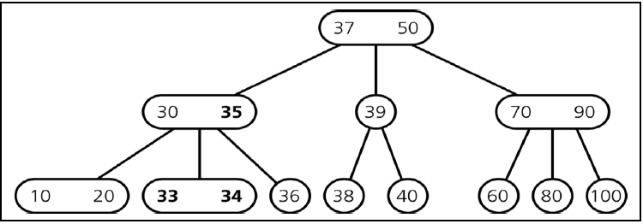

Consider this 2-3-tree:

Draw the tree after inserting 25. Show the process with a series of sketches. Then show the deletion of 10.

***Exercise 2***

Create a BlueJ project that creates a *TreeSet*. Insert some values and use the Object Inspector to examine the structure of the tree. Delete some elements and again use the Object Inspector to examine the structure of the tree.